Exp. No: 1
Transformation between Cartesian, Cylindrical and Spherical Coordinate Systems
Test Case (i): Cartesian to Cylindrical and Spherical Coordinates
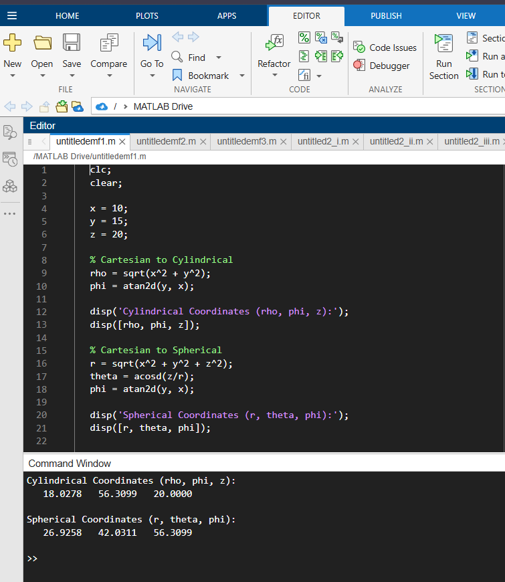Test Case (ii): Cylindrical to Cartesian and Spherical Coordinates
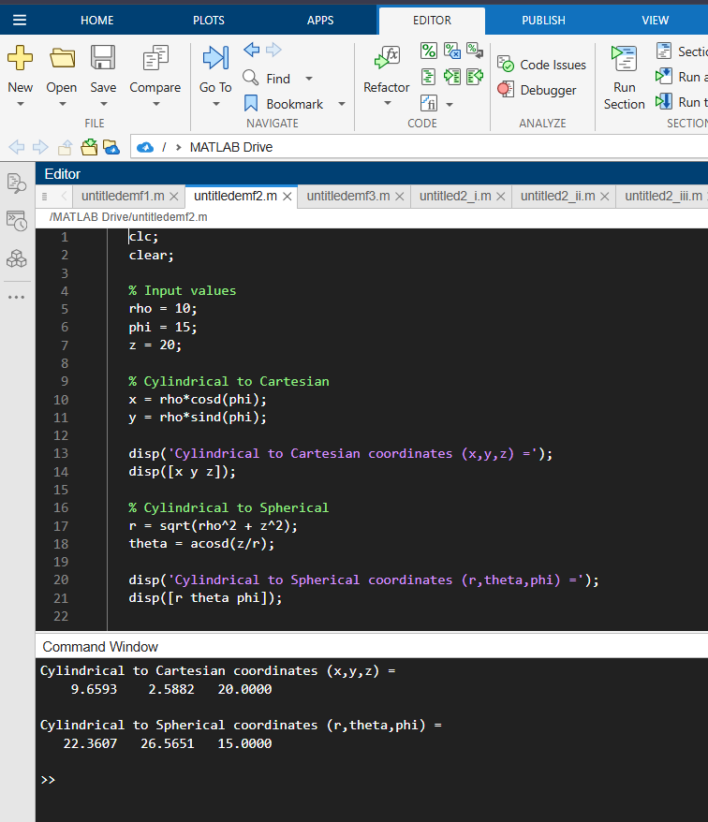
Test Case (iii): Spherical to Cartesian and Cylindrical Coordinates
